Q.1

INPUT:-

while True:

    input_string = input("Enter here \n").lower()

    reversed_string = ""

    for i in input_string:

        reversed_string = i + reversed_string

    if (input_string == reversed_string):

            print("Yes,it is a palindrome")

    else:

            print("No, it is not a palindrome")

    if input("Do you want check another word?(yes/no) ").lower() !="yes":

        break

print("Thank You")

Output:-

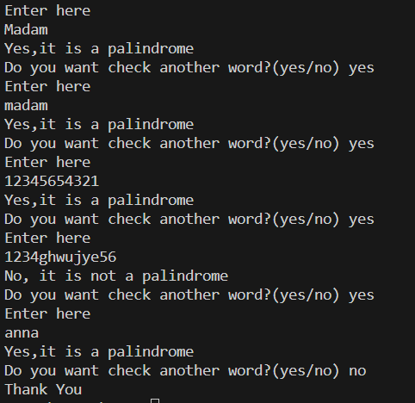

Q.2

INPUT:-

for i in range(200,401):

    numbers =str(i)

    is_even = True

    for j in numbers:

        if int(j)%2:

            is_even = False

    if is_even:

        print(numbers,end=", ")

OUTPUT:-

